The density is fill factor because the way they measure it is to fill it with water and evaporate the water and see the mass decrease.

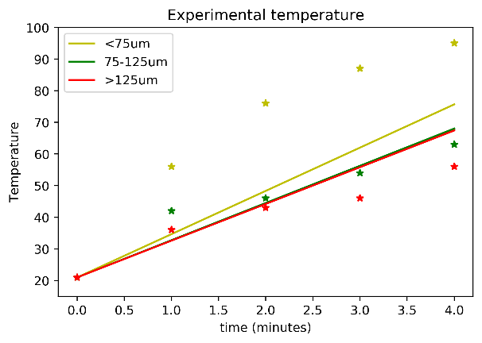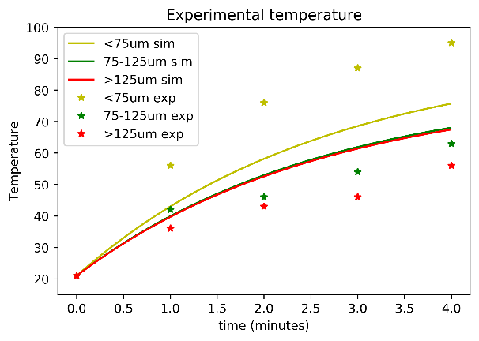

New fitting line:

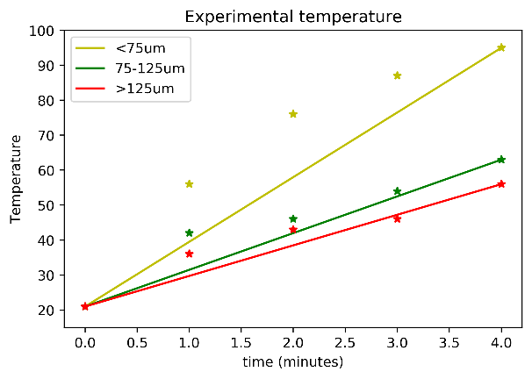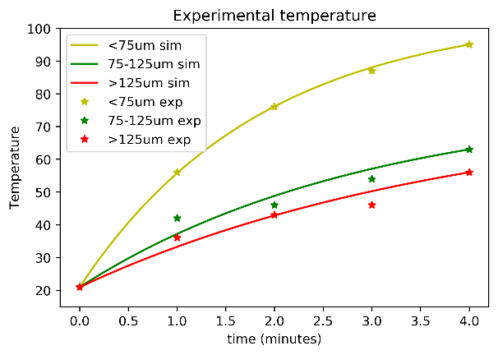

|  |  |  |  |  |  |
| --- | --- | --- | --- | --- | --- |
|  | **σ/x** | **lower** | **upper** | **fill factor** | mean |
| **<75** | 0.3027 | 0.6727 | 0.7831 | 0.7279±0.0552 | 0.463547 |
| **>75 <125** | 0.1448 | 0.6259 | 0.7494 | 0.6876±0.0618 | 0.445221 |
| **>125** | 0.1286 | 0.6227 | 0.746 | 0.6844±0.0616 | 0.443599 |
|  |  |  |  |  |  |
|  | **linear const value** | **Conducting** | Heating | E_field_squared*eps/(fill_factor)*loss_factor | heating_coefs/E_field_pre_factor |
| **<75** | 568.5227 | 0.267006 | 44.80761 | 0.130162 | 344.2452 |
| **>75 <125** | 375.1185 | 0.16804 | 19.10075 | 0.111965 | 170.5963 |
| **>125** | 316.6178 | 0.126536 | 13.92342 | 0.110543 | 125.9544 |